Name – Shubham Rajendra Gorade
PRN – 260840320163

Q1 -
Code :
import java.util.*;

public class Result {

int Student_ID;
String Student_Name;
String Subject_Name;
int Marks_Obtained;
char Grade;
String Exam_Date;

public Result(int student_ID, String student_Name, String subject_Name, int marks_Obtained, char grade,
String exam_Date) {
Student_ID = student_ID;
Student_Name = student_Name;
Subject_Name = subject_Name;
Marks_Obtained = marks_Obtained;
Grade = grade;
Exam_Date = exam_Date;
}

public int getStudent_ID() {
return Student_ID;
}

public void setStudent_ID(int student_ID) {
Student_ID = student_ID;
}

public String getStudent_Name() {
return Student_Name;
}

public void setStudent_Name(String student_Name) {
Student_Name = student_Name;
}

public String getSubject_Name() {
return Subject_Name;
}

public void setSubject_Name(String subject_Name) {
Subject_Name = subject_Name;
}

public int getMarks_Obtained() {
return Marks_Obtained;
}

public void setMarks_Obtained(int marks_Obtained) {
Marks_Obtained = marks_Obtained;
}

public char getGrade() {
return Grade;
}

public void setGrade(char grade) {
Grade = grade;
}

public static void main(String[] args) {

System.out.println("Enter Student Data");
Result obj = new Result(101, "Shubham", "Math", 20, 'B', "25-09-2026");

}

}

Output :

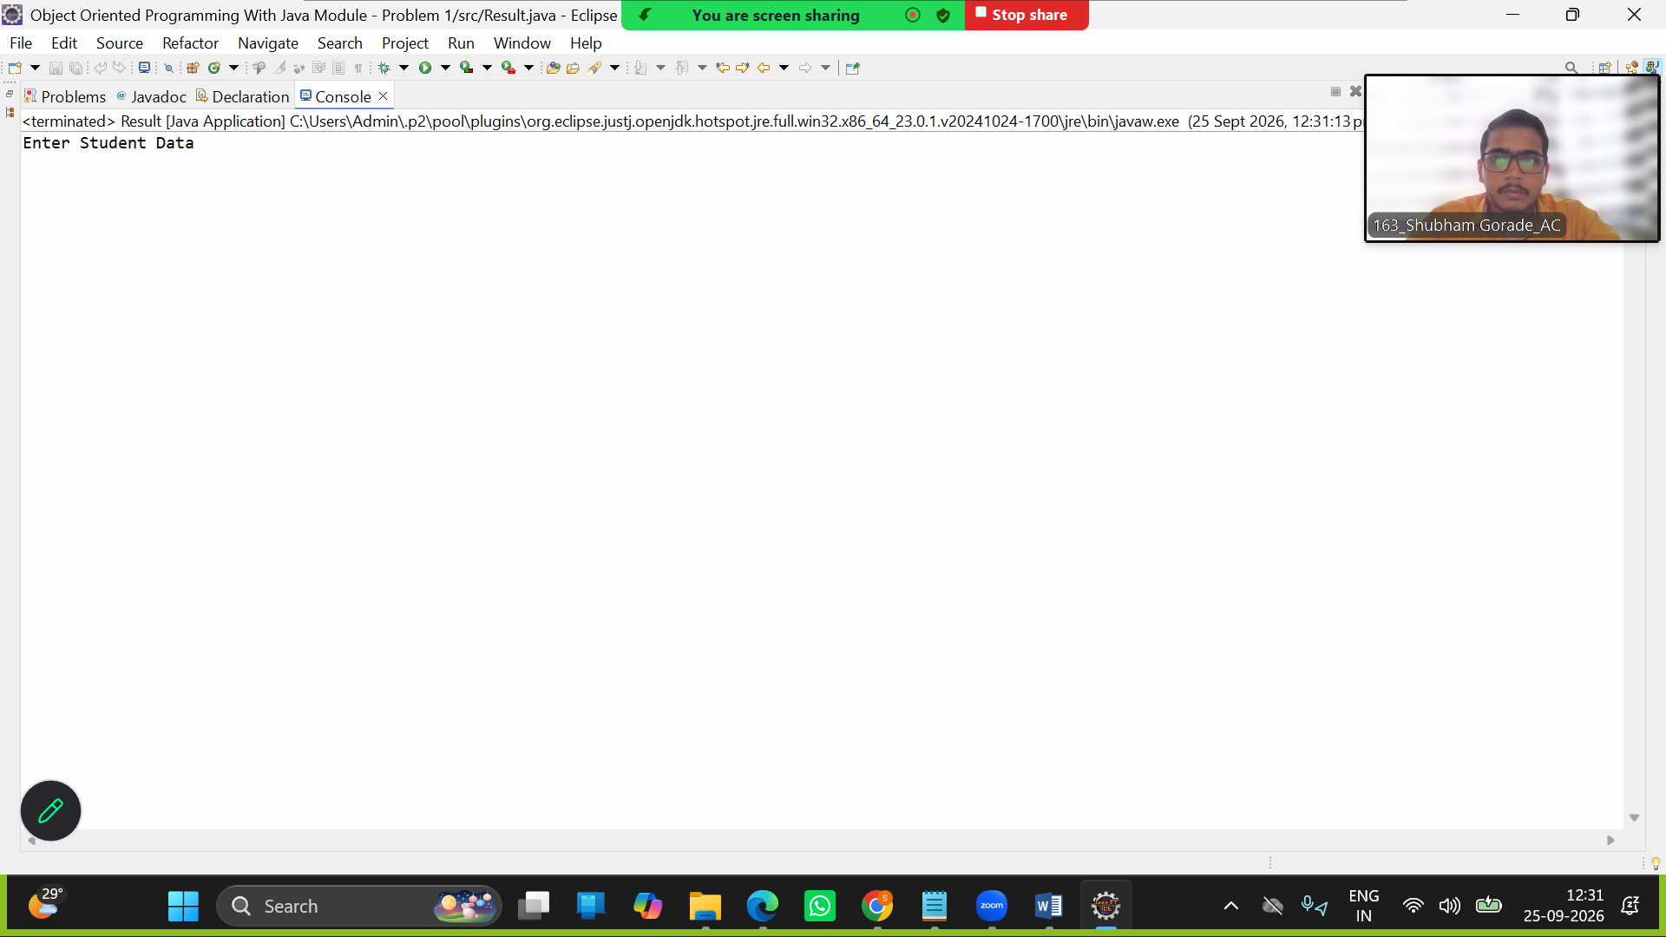

Q2 -
Code :
import java.util.*;
public class Account {
public int AccountNumber;
public static double balance;

public void withdraw(double amount) {
}
}

import java.util.*;
public class SavingsAccount extends Account {

public void acc(int a) {
AccountNumber = a;
}
public void addBal(double bal) {
balance = bal;
if(balance<500) {
System.out.println("Add more moneny in account balance should be minminum 500");
}
}

public static void withdrawb(double bal) throws InsufficientBalanceException{
if(balance-bal<=500) {
throw new InsufficientBalanceException("Explanation: Savings account must maintain minimum balance of 500.");
}

else {
balance = balance - bal;
System.out.println("Remaining Balance = "+balance);
}
}
}

import java.util.*;
public class CurrentAccount extends Account{
public void addBall(double bal) {
balance = bal;
if(balance<0) {
System.out.println("Add more moneny in account balance should not be negative");
}
if(bal<500) {
System.out.println("Add more moneny in account balance should be minminum 500");
}
}

public static void withdrawbb(double bal) throws InsufficientBalanceException {
if(bal>balance) {
throw new InsufficientBalanceException("Withdrawal denied due to insufficient balance");
}
}
}

import java.util.*;
public class InsufficientBalanceException extends Exception {
InsufficientBalanceException(String s) {
super(s);
}
public static void main(String[] args) {

Scanner sc = new Scanner(System.in);
SavingsAccount sav = new SavingsAccount();
CurrentAccount c = new CurrentAccount();

int choice;

do {
System.out.println("1.Account type");
System.out.println("2.Enter account No");
System.out.println("3. Add Money");
System.out.println("4.Withdraw");
System.out.println("5.Exit");

choice = sc.nextInt();

switch(choice) {
case 1 :
{
System.out.println("Enter account type");
String s = sc.next();

}

case 2:{
System.out.println("Enter account Number");
sc.nextLine();
int a = sc.nextInt();
sav.acc(a);

}

case 3 :{
System.out.println("Enter Money");
double b = sc.nextInt();
c.addBall(b);

}

case 4 : {
System.out.println("Withdarw Money");
double d = sc.nextInt();

try {
CurrentAccount.withdrawbb(d);
}

catch(InsufficientBalanceException e) {
System.out.println(e.getMessage());
}

try {
SavingsAccount.withdrawb(d);
}

catch(InsufficientBalanceException e1) {
System.out.println(e1.getMessage());
}
break;

}

default : {
System.out.println("Enter correct Choice");
break;
}
}
}while(choice==5);

}

}

Output :

